**Mobile Computing**

**Assignment 1**



**Name: Jaskirat Singh**

**Roll number: 05413202717**

**Section: CSE-1 (8th Semester)**

# Que.1 Discuss the GPRS protocol stack with a diagram. (4)

GPRS Protocol Stack

The GPRS protocol stack enables the software within a GPRS handset or mobile station to be organised in a logical fashion enabling the different functions to be layered in a logical fashion – layers include SNDCP, LLC, RLC and MAC areas.

The GPRS protocol stack is a key element within the overall GPRS handset or base station. It enables the different functions to be split into different layers so that the correct priorities.

The protocol stack enables the exchanges to take place in the required fashion and to be managed in an orderly fashion.

OSI layer model

Protocol stacks are layered and in broad terms follow the OSI layer model. The OSI, Open Systems Interconnection model is a conceptual model that characterizes and standardises the communication functions of a system like a telecommunications or computer system, but in this case the GPRS system. The OSI model does this without regard of their underlying internal structure and technology.

The aim of the OSI model is the interoperability of diverse communication systems with standard protocols. The model partitions a communication system into abstraction layers. The original version of the model defined seven layers, although this is often tailored to suit an individual application or system.

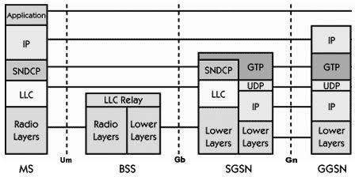

# Q2. Describe the GSM architecture and its service detail. Explain about GSM authentication and security. (5)

Function of Components :

1. Mobile station (MS) : It refers for mobile station. Simply, it means a mobile phone.
2. Base trans receiver system (BTS) : It maintains the radio component with MS.
3. Base station controller (BSC) : Its function is to allocate necessary time slots between the BTS and MSC.
4. Home location register (HLR) : It is the reference database for subscriber parameter like subscriber’s ID, location, authentication key etc.
5. Vistor location register (VLR) : It contains copy of most of the data stored in HLR which is temporary and exist only until subscriber is active.
6. Equipment identity register (EIR) : It is a database which contains a list of valid mobile equipment on the network.
7. 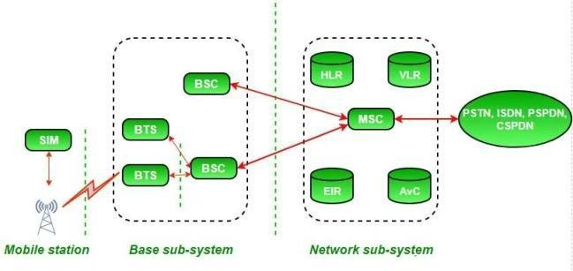Authentication center (AuC) : It perform authentication of subscriber.

Mobile Station Authentication

The GSM network authenticates the identity of the subscriber through the use of a challenge- response mechanism. A 128-bit Random Number (RAND) is sent to the MS. The MS computes the 32-bit Signed Response (SRES) based on the encryption of the RAND with the authentication algorithm (A3) using the individual subscriber authentication key (Ki). Upon receiving the SRES from the subscriber, the GSM network repeats the calculation to verify the identity of the subscriber.

The individual subscriber authentication key (Ki) is never transmitted over the radio channel, as it is present in the subscriber's SIM, as well as the AUC, HLR, and VLR databases. If the received SRES agrees with the calculated value, the MS has been

successfully authenticated and may continue. If the values do not match, the connection is terminated and an authentication failure is indicated to the MS.

The calculation of the signed response is processed within the SIM. It provides enhanced security, as confidential subscriber information such as the IMSI or the individual subscriber authentication key (Ki) is never released from the SIM during the authentication process.

SMS Service

Most of the service providers charge their customer's SMS services based on the number of text messages sent. There are other prime SMS services available where service providers charge more than normal SMS charge. These services are being availed in collaboration of Television Networks or Radio Networks to demand SMS from the audiences.

Most of the time, the charges are paid by the SMS sender but for some services like stocks and share prices, mobile banking facilities, and leisure booking services, etc. the recipient of the SMS has to pay for the service.

GPRS Services

Using GPRS service, you can browse, play games on the Internet, and download movies. So a service provider will charge you based on the data uploaded as well as data downloaded on your mobile phone. These charges will be based on per Kilo Byte data downloaded/uploaded.

Additional parameter could be a QoS provided to you. If you want to watch a movie, then a low QoS may work because some data loss may be acceptable, but if you are downloading a zip file, then a single byte loss will corrupt your complete downloaded file.

Another parameter could be peak and off peak time to download a data file or to browse the Internet.

# Q3. Discuss the feature of HiperLAN (2)

* Ans. HiperLAN stands for High performance LAN. While all of the previous technologies have been designed specifically for an adhoc environment, HiperLAN is derived from traditional LAN environments and can support multimedia data and asynchronous data effectively at high rates (23.5 Mbps).
* A LAN extension via access points can be implemented using standard features of the HiperLAN/1 specification. However, HiperLAN does not necessarily require any type of access point infrastructure for its operation.
* HiperLAN was started in 1992, and standards were published in 1995. It employs the 5.15GHz and 17.1 GHz frequency bands and has a data rate of 23.5 Mbps with coverage of 50m and mobility< 10 m/s.
* It supports a packet-oriented structure, which can be used for networks with or without a central control (BS-MS and ad-hoc). It supports 25 audio connections at 32kbps with a maximum latency of 10 ms, one video connection of 2 Mbps with 100 ms latency, and a data rate of 13.4 Mbps
* HiperLAN/1 is specifically designed to support adhoc computing for multimedia systems, where there is no requirement to deploy a centralized infrastructure. It effectively supports MPEG or other state of the art real time digital audio and video standards.
* The HiperLAN/1 MAC is compatible with the standard MAC service interface, enabling support for existing applications to remain unchanged.
* HiperLAN 2 has been specifically developed to have a wired infrastructure, providing short-range wireless access to wired networks such as IP and ATM.

# Q4. Explain the following: (5)

1. **Zigbee**

Ans. ZigBee is a Personal Area Network task group with low rate task group 4. It is a technology of home networking. ZigBee is a technological standend created for controlling and sensor the network. As we know that ZigBee is Personal Area network of task group 4 so it is based on IEEE 802.14.4 and it is created by Zigbee Aliance.

Fact’s:

Operates in personal area network. It is a device to device network

Architecture of Zigbee:

Zigbee architecture is a combination of 6 layers.

Application Layer Application Interface Layer Security Layer Network Layer

Medium Access Control Layer Physical Layer

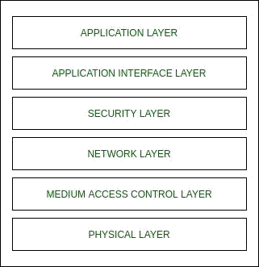

The Application layer is present at the user level.

The Application Interface Layer, Security Layer and Network Layer are the Zigbee Aliance and they are used to sore data and they uses stack.

Medium Access control and the Physical layer are the IEEE 802.15.4 and they are hardware which are silicon means they accept only 0 and 1. Types of ZigBee Devices:

Zigbee Coordinator Device – It communicate with routers. This device is used for connecting the devices.

Zigbee Router – It used for passing the data between devices. Zigbee End Device – It is the device which is going to be controlled

# WiMAX

WiMAX is Acronym for Worldwide Interoperability for Microwave Access. Based on Wireless MAN technology. A wireless technology optimized for the delivery of IP centric services over a wide area. A scalable wireless platform for constructing alternative and complementary broadband networks. A certification that denotes interoperability of equipment built to the IEEE 802.16 or compatible standard. The IEEE

802.16 Working Group develops standards that address two types of usage models – A fixed usage model (IEEE 802.16-2004). A portable usage model (IEEE 802.16e).

# RFID

Radio Frequency Identification (RFID) is a method which is used to track or identify a object by radio transmission uses over the web. Data digitally encoded in RFID tag which might be read by the reader. This is device work as a tag or label during which data read from tags which is stored in database through reader as compared traditional barcodes and QR codes. It is often read outside the road of sight either passive or active RFID.

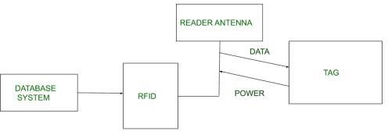

There are two types of RFID :

* 1. Passive RFID –

In this device, RF tags are not attached by a power supply and passive RF tag stored their power. When it is emitted from active antennas and the RF tag are used specific frequency like 125-134MHZ as low frequency, 13.56MHZ as a high frequency and 856MHZ to 960MHZ as ultra-high frequency.

* 1. Active RFID –

In this device, RF tags are attached by a power supply that emits a signal and there is an antenna which receives the data.

Working Principle of RFID :

Generally, RFID uses radio waves to perform AIDC function. AIDC stands for Automatic Identification and Data Capture technology which performs object identification and collection and mapping of the data.

An antenna is an device which converts power into radio waves which are used for communication between reader and tag. RFID readers retrieve the information from RFID tag which detects the tag and reads or writes the data into the tag. It may include one processor, package, storage and transmitter and receiver unit.

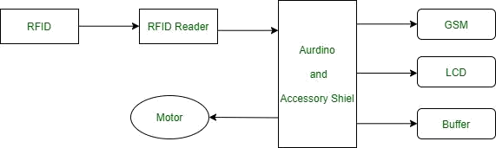

**Q5. Explain the WAP architecture in brief.**

**Ans.** Wireless Application Protocol

WAP stands for Wireless Application Protocol. It is a protocol designed for micro-browsers and it enables the access of internet in the mobile devices. It uses the mark-up language WML (Wireless Markup Language and not HTML), WML is defined as XML 1.0 application. It enables creating web applications for mobile devices. In 1998, WAP Forum was founded by Ericson, Motorola, Nokia and Unwired Planet whose aim was to standardize the various wireless technologies via protocols.

WAP protocol was resulted by the joint efforts of the various members of WAP Forum. In 2002, WAP forum was merged with various other forums of the industry resulting in the formation of Open Mobile Alliance (OMA).

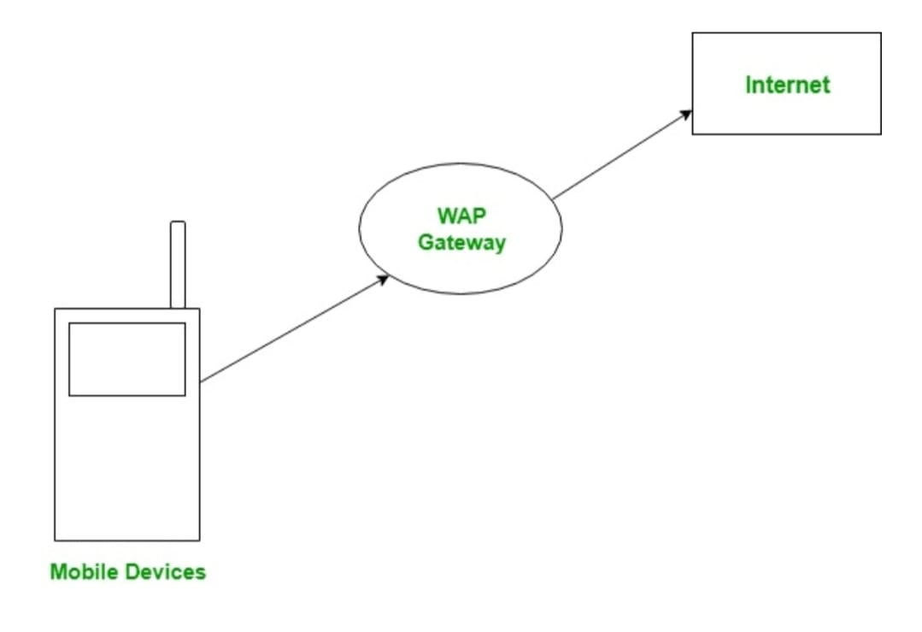

WAP Model:

The user opens the mini-browser in a mobile device. He selects a website that he wants to view. The mobile device sends the URL encoded request via network to a WAP gateway using WAP protocol.

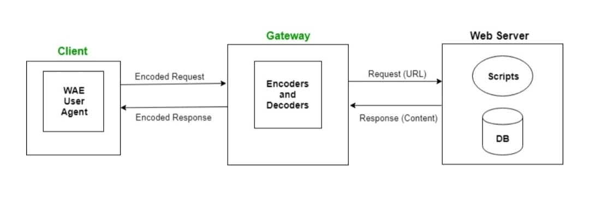

The WAP gateway translates this WAP request into a conventional HTTP URL request and sends it over the internet. The request reaches to a specified Web server and it processes the request just as it would have processed any other request and sends the response back to the mobile device through WAP gateway in WML file which can be seen in the micro-browser.

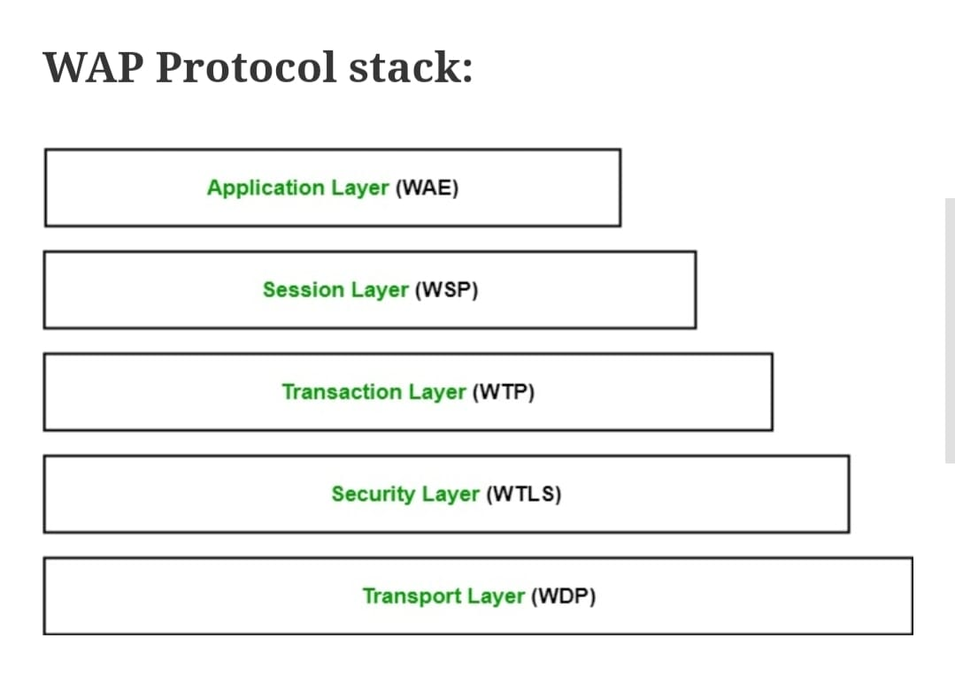

Application Layer:

This layer contains the Wireless Application Environment (WAE). It contains mobile device specifications and content development programming languages like WML.

Session Layer:

This layer contains Wireless Session Protocol (WSP). It provides fast connection suspension and reconnection.

Transaction Layer:

This layer contains Wireless Transaction Protocol (WTP). It runs on top of UDP (User Datagram Protocol) and is a part of TCP/IP and offers transaction support.

Security Layer:

This layer contains Wireless Transaction Layer Security (WTLS). It offers data integrity, privacy and authentication.

Transport Layer:

This layer contains Wireless Datagram Protocol. It presents consistent data format to higher layers of WAP protocol stack.